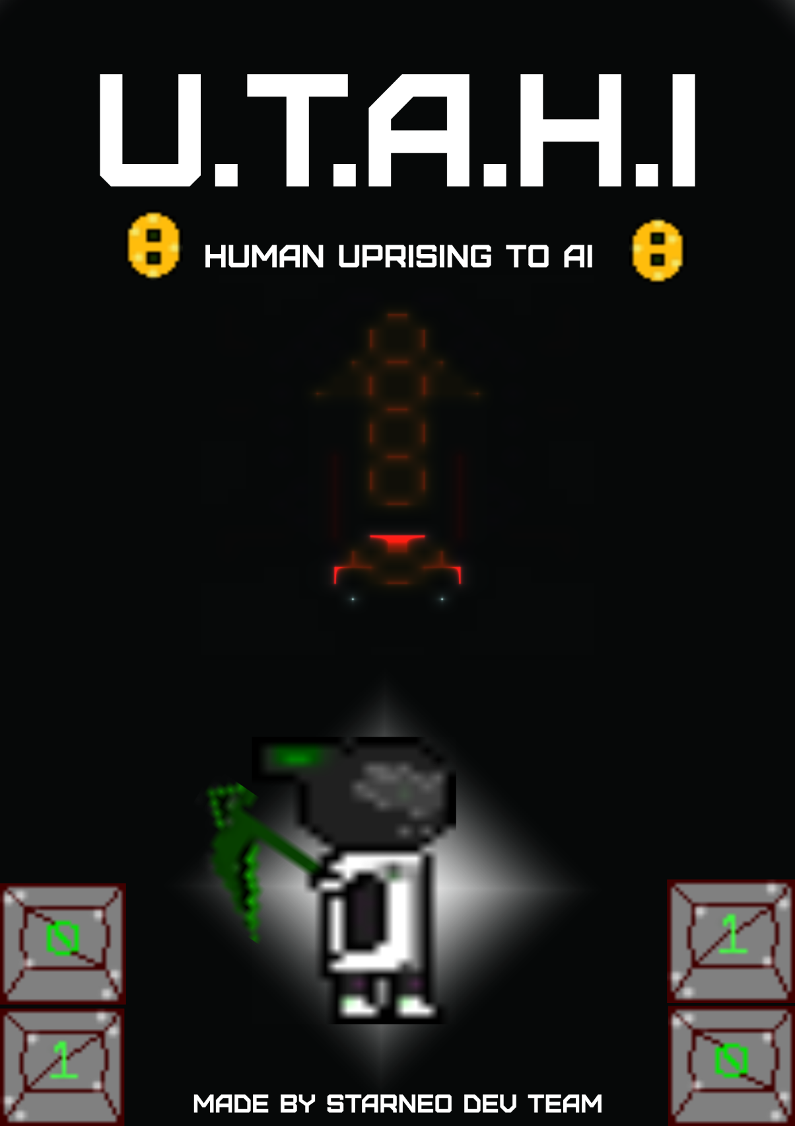

Salman Al-Samiri, Alexander Bowes, Rianlee Pineda | Game Fleadh | February 28, 2020

UTAHI

StarNeo Dev Team

# The Game Plot

The World at some point in the future seems to be on the edge of extinction, but The Player is one of the few humans left on the planet, using their knowledge and experience have managed to transfer their soul and mind into an artifactual intelligence.

UTAHI (Human Uprising To AI) is their hope of finding a way to build a life within the world of ones and zeros, or if there is any chance for their theory to be accurate or even real a pathway to an alternative universe, where the planet is still intact and in peace where they could start a new life.

The path ahead is not an easy path the internet is filled with bugs, viruses and many other chaotic dangers that would threaten UTAHI’s life and the ability to reach their goal.

# The Work Process

We are Students in DT228 2nd year Computer Science at TU-Dublin We have formed StarNeo Dev Team to develop our first video game for Game Fleadh and for fun.

The Team has divided the workload into three roles Salman is handling the graphics and the game plot, Rianlee is handling the soundtracks and programming and Alexander is the one who designs the maze and part of the coding.

The game is made using game maker ide v 1.2, purely in code and original assets that has been made from scratch.

# The Game Play

The game is a 2D maze game that require the player to defeat the bugs that stands in their way, get the firewall down and obtain the key to continue in their journey.

The game style took inspiration from the retro game style of games like the Legend of Zelda and Bomberman. The player start at the beginning of the maze navigating their way to the switch button to deactivate the fire wall, because as if the player attempts to exit the maze while its up they will getting damaged, after that obtaining the key is the next stop as it holds the access code to open the door and get through.